Assessment Schedule – 2016

Calculus: Apply the algebra of complex numbers in solving problems (91577)

Evidence Statement
Q1 | Expected Coverage | Achievement  (u) | Merit  (r) | Excellence  (t)
(a) | s clearly marked at (1, 2) | Correct solution.
(b) | A = –6 | Correct solution.
(c) | 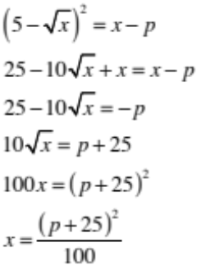 | Correct 3rd line. | Correct solution with correct, logical working.
(d) | 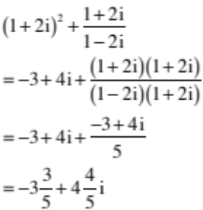 | Correct calculation of  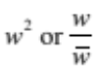 | Correct solution with working clearly shown.
(e) | 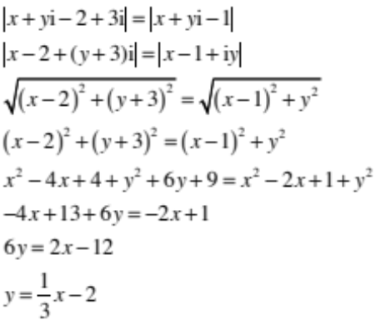  Gradient = |  | Correct 4th line. | Correct gradient with correct working.

NØ | N1 | N2 | A3 | A4 | M5 | M6 | E7 | E8
No response; no relevant evidence. | ONE partial Solution. | 1u | 2u | 3u | 1r | 2r | 1t with minor error(s). | 1t

Q2 | Expected Coverage | Achievement  (u) | Merit  (r) | Excellence  (t)
(a) | 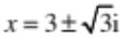 | Correct solution.
(b) | 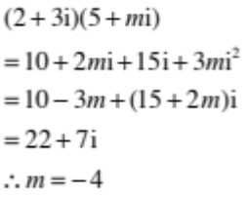 | Correct solution.
(c) | 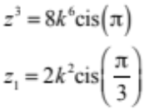  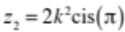  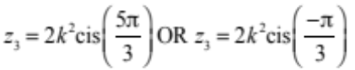 | 1 correct solution. | 3 correct solutions.
(d) | 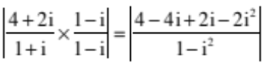  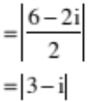  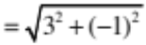  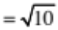 | 6 – 2i in numerator. | Correct solution with working clearly shown.
(e) | 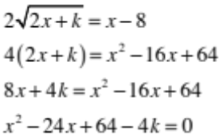  One solution  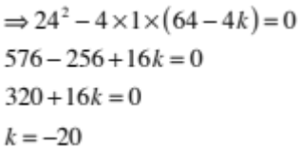 |  | Correct equation without 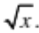 | Correct solution.

NØ | N1 | N2 | A3 | A4 | M5 | M6 | E7 | E8
No response; no relevant evidence. | ONE partial Solution. | 1u | 2u | 3u | 1r | 2r | 1t with minor error(s). | 1t

Q3 | Expected Coverage | Achievement  (u) | Merit  (r) | Excellence  (t)
(a) | 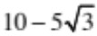 | Correct solution.
(b) | 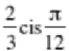 | Correct exact solution.
(c) | 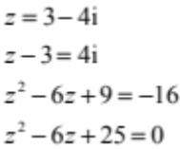  Other factor is 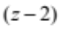  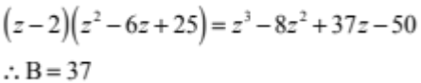 | Finding (z,–2) is a factor. | Correct solution.
(d) | Let and  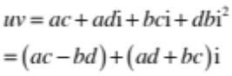  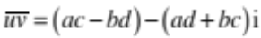  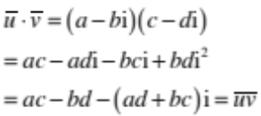 | Correct expression for LHS or RHS. | Correct solution.
(e) | Let and  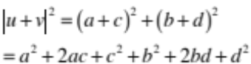  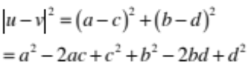  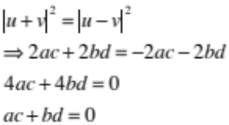  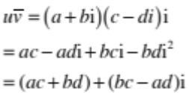  But from above  is purely imaginary |  | Correct expressions for  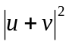 and  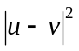  Expanded. | Correct solution.

NØ | N1 | N2 | A3 | A4 | M5 | M6 | E7 | E8
No response; no relevant evidence. | ONE partial Solution. | 1u | 2u | 3u | 1r | 2r | 1t with minor error(s). | 1t

Cut Scores
Not Achieved | Achievement | Achievement with Merit | Achievement with Excellence
0–8 | 9–14 | 15–20 | 21–24

